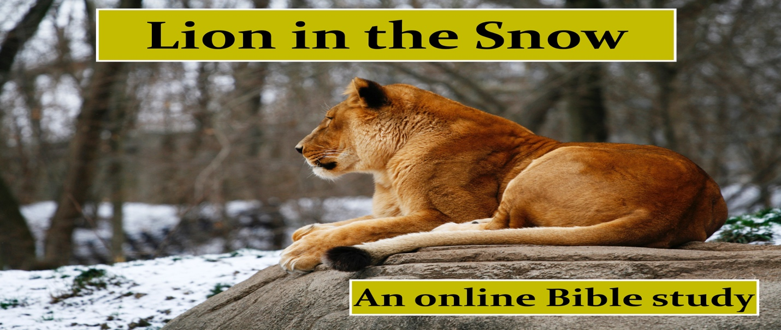
CHAPTER 1 – STUDY GUIDE

BASED ON 2 SAMUEL 23:20-21, CREATE A LIST OF ACCOMPLISHMENTS FOR BENAIAH’S RESUME:
- A valiant warrior

- _____________________________________________________________

- _____________________________________________________________

- _____________________________________________________________

The LORD used those accomplishments to bring Benaiah to what position:

_____________________________________________________________

In today’s terms, what sort of position do you think being bodyguard to King David equates to:

Wishing you hadn’t done something is a REGRET OF ___________________.

Wishing you had done something but didn’t is a REGRET of ____________________.

When we refuse to act, we may miss God-ordained ___________________________.

______________ is defined as “doing the best you can with what you have and where you are.

Describe an area where you have experienced success:

Prayerfully consider the GIFTS the Lord has given you. DESCRIBE the dreams the Lord has planted in your heart for those gifts that you have not been bold enough to use yet. This is an important exercise, so take your time and “chew” on it a little. We worship a limitless God. Dream Big. This book is about building our personal resume by chasing the lions in front of us.

I suggest you get a journal and jot down your thoughts over the next few days. REMEMBER SOMETIMES THE BIGGEST LION IN OUR PATH IS OUR OWN FEAR!

Once you have recorded your dreams, move on to Lesson 2.

